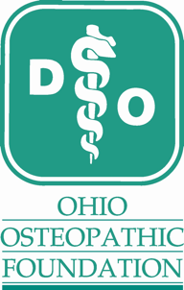

Ohio Osteopathic Foundation

OOA District Academy
CME Seminar Co-Sponsor Approval Form

Program Title: ____________________________________________

Program date(s): ________________

Needs assessment/process (please include any supporting documents):
______________________________________________________________________________________________________________________________________

Program length (in credit hours): _________

Location and venue: ______________________________

Registration fees (include all registration types): ______________________________________________________________________________________________________________________________________

Anticipated number of registrants: ______________

Potential commercial support: _______________

Program Co-Sponsor: ________________________

Program Co-sponsor contact person & information: ______________________________________________________________________________________________________________________________________

Approval form must be submitted no later than 60 days before a program expects to begin. CME fees will be made payable to the Ohio Osteopathic Foundation. Please make check payable to the Ohio Osteopathic Foundation. Upon approval, you’ll be need to proceed to the CME checklist. As a co-sponsor of the OOF, you are responsible for providing all requisite program documentation and fees. By signing below, you indicate information provided is accurate as of the time of submission.

______________________________ _________
Program co-sponsor authorized agent Date

___________________________ Approved/Denied ____________
OOA Executive Director Date

